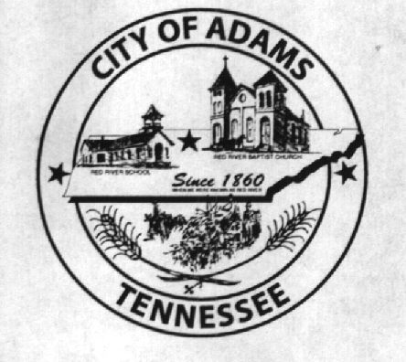
City Meeting
April 4, 2017

The Adams Board of Commissioners met in regular session on Tuesday, April 4, 2017, at 7:00 p.m. in the Bell School Auditorium. Mayor Mary Mantooth, Wayne Evans and Will David Goodman were present.

Item 1: Open With Prayer

Mayor Mantooth asked Denny Lowe to open with a word of prayer. Following the word of prayer, Mayor Mantooth requested all in attendance stand for the Pledge of Allegiance.

Item 2: Minutes

Minutes of the March 7, 2016 meeting was read. There being no additions or corrections, Mayor Mantooth moved that the minutes be approved as read. The minutes stand approved with no corrections or additions.

Item 3: Financial Report

The financial report was presented. The City Recorder presented the Commissioners with a detailed list of amounts transferred between line items done on March 7, 2017. The detail listing is included as an attachment herein. There being no corrections, Mayor Mantooth moved that the financial report be approved as presented. The financial report stands approved with no corrections or additions.

Item 4: Update on Plumbing Issue at Bell School

The City Recorder informed the commissioners that Jack Baggett submitted a proposal for the new septic field lines. Another company had also submitted a bid, but the City Recorder was having difficulty receiving a third bid. The Commissioners agreed to have Mr. Baggett come out and test the existing field lines and if they needed to be replaced, the city would hire Mr. Baggett to complete the work.

Item 5: Resolution No. 2017-006 Creating a Credit Line with CoOp

The City Recorder read the title for Resolution Number 2017-006, a Resolution allowing the Mayor to Create a Credit Line Account with CoOp. Motion was made by Vice Mayor Evans to approve Resolution Number 2017-006. Commissioner Goodman seconded the motion. Motion carried by voice vote: 2 for; 0 opposed.
Item 6: Resolution No. 2017-007 Participation in LGIP

The City Recorder read the title for Resolution Number 2017-007, a Resolution Allowing the City of Adams to Participate in the State of Tennessee Local Government Investment Pool. Vice Mayor Evans made a motion to approve Resolution No. 2017-007. Commissioner Goodman seconded the motion. Motion carried by voice vote: 2 for; 0 opposed.

Item 7: Request for Donations

The City Recorder presented requests for donations from Handsome Dave Fun Run, JoByrns High School History Department and 4-H. Vice Mayor Evans made a motion to approve the donations and amounts as follows: $100 to Handsome Dave Fun Run; $125 to JBHS History Department; and $150 to 4-H. Commissioner Goodman seconded the motion. Motion carried by voice vote: 2 for; 0 opposed.

Item 8: Automatic Mutual Aid Agreement with North Robertson

Mayor Mantooth was presented with and signed the Automatic Mutual Aid Agreement with North Robertson Fire Department.

Item 9: Proposed Capital Outlay Projects

The Commissioners discussed proposed capital outlay projects relating to the general fund and each of the departments. Since the Commissioners were indecisive about the specific capital outlay projects presented for the general fund, a total of $104,000 would be set aside and specific projects would be approved at a later time. The museum department asked for $1,000 to be set aside for replacing the glass in some of the cabinets. The fire department requested $50,000 to build a new bay as an addition to the fire hall. The recreation department requested funds be set aside for lighting for the softball field, but would have to get back to them as far as an approximate cost. The aforementioned capital outlay projects will be submitted for formal approval by the Commissioners in next month’s meeting via the annual budget ordinance.

Item 10: Updates from the Departments

There was nothing to report from any department

Item 11: Other Business

Mayor Mantooth suggested revisiting the conversation with CSX regarding the closing of the railroad crossing on Murphy Street. Mayor Mantooth went on to say if CSX would ensure Railroad Street and the individual’s driveway located on the other side of the tracks would continue to comply with our zoning ordinance or absorb the cost(s) associated with making them comply, the City would consider closing the crossing for the final proposed amount of $20,000.

There being no further business, Mayor Mantooth moved to adjourn. Vice Mayor Evans seconded the motion. Meeting adjourned at 8:08 p.m.

Respectfully submitted,

________________________________ ____________________________________
Dawn Ray, City Recorder Mary Mantooth, Mayor

Attachment to April 7, 2017 City Meeting Minutes
Transfers Between Accounts
Done by the City Recorder on 3/7/2017
Account Number | Description | Debit | Credit
110-41000-236 | Donations | $1,000.00
110-41000-310 | Office Supplies | $2,000.00
110-41000-320 | Computer | $ 250.00
110-41000-510 | Insurance | $ 800.00
110-41000-778 | X-Mas in Park | $1,500.00
110-41810-241 | Electric | $1,000.00
110-41810-245 | Phone | $ 250.00
110-41810-265 | Grounds | $4,000.00
110-41000-233 | Subscriptions |  | $ 100.00
110-41000-235 | Dues & Fees |  | $ 100.00
110-41000-254 | Mowing Lien |  | $ 400.00
110-41000-776 | Water Loan |  | $ 500.00
110-41550-298 | City/Rob Co Taxes |  | $2,000.00
110-41810-242 | Water |  | $1,200.00
110-41810-244 | Gas |  | $2,500.00
110-41810-254 | Landscape |  | $4,000.00
 | TOTAL | $10,800.00 | $10,800.00

