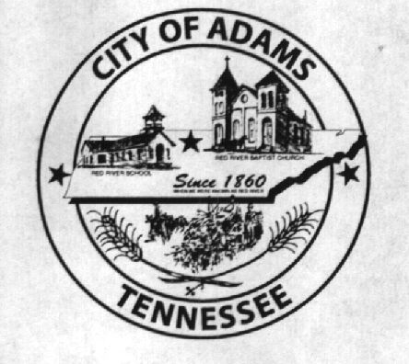
City Meeting
December 6, 2016

The Adams Board of Commissioners met in regular session on Tuesday, December 6, 2016, at 7:00 p.m. in the Bell School Auditorium. Mayor Mary Mantooth, Wayne Evans and Will David Goodman were present.

Item 1: Open With Prayer

Mary Mantooth asked Denny Lowe to open with a word of prayer. Following the word of prayer, Mary Mantooth requested all in attendance stand for the Pledge of Allegiance.

Wayne Evans read the official certificate of election.

Official Certificate of Election

We, the undersigned members of the Robertson County Election Commission, do hereby certify that we held a Municipal Election for the City of Adams on Tuesday, November 8, 2016, in all of the voting precincts in this city, according to law, for the purpose of electing the offices of City Commissioner 4 year term and City Commissioner 2 year unexpired term, and that we have canvassed the returns of said election as required by law, and we do hereby certify that the following 1 page tabulation are true, correct, and complete accounting of the results by precinct and county of said election as established by the canvassing of the returns, this 21st day of November, 2016.

City Commissioner
Mike Harbert 90
Mary M. Mantooth 127

City Commissioner (unexpired term)
Chris Cockrill 85
Will David Goodman 122

/s/ Raymond Knowles
/s/ Patricia Morris
/s/ Sharon Hargraves
/s/ Marie Mobley
/s/ Andrew Heard

The said Mary Mantooth and Will David Goodman then took and subscribed to an oath of office for the City of Adams in words and figures as follows:

“I, Mary Mantooth/Will David Goodman, having been elected to the office of Commissioner of Adams, Tennessee, a municipal corporation, do solemnly swear that I will support the Constitution of the United States and the Constitution of the State of Tennessee and will faithfully perform the duties of said office to the best of my skill and ability without favor or partiality.”

Sword and subscribed before me, December 6, 2016.

___________________________________
Dawn M. Ray, City Recorder

Dawn Ray then asked for a nomination for Mayor. Wayne Evans nominated Mary Mantooth, Will David Goodman seconded the nomination. Roll Call Vote: Evans – Aye, Mantooth – Abstained, Goodman – Aye. Mary Mantooth accepted the position.

Dawn Ray then asked for a nomination for Vice Mayor. Mary Mantooth nominated Wayne Evans, Will David Goodman seconded the nomination. Roll Call Vote: Evans: Abstained, Mantooth – Aye, Goodman – Aye. Wayne Evans accepted the position.

Item 2: Minutes

Minutes of the November 1, 2016, meeting was read. There being no additions or corrections, Mayor Mantooth moved that the minutes be approved as read. The minutes stand approved with no corrections or additions.

Item 3: Financial Report

The financial report was presented. There being no corrections, Mayor Mantooth moved that the financial report be approved as presented. The financial report stands approved with no corrections or additions.

Item 4: ADA Compliant Ramp

The City Recorder asked the Commissioners if they were ready to make a decision on the ADA compliant ramp. Wayne Evans stated that he still had someone he needed an additional month, so the matter was postponed until next meeting.

Item 5: Moss’s Lease

The City Recorder informed the Board of Commissioners Moss’s Restaurant’s lease is due to expire at the end of the month and presented them with a list of expenses the city has incurred for the rented space over the last 10 months. Wayne Evans made a motion to allow Moss’s to renew their lease at the current monthly rent of $710. Will David Goodman seconded the motion. Motion carried by voice vote: 2 for; 0 opposed.

Item 6: Updates from the Departments

Fire Department – Chief Brown had nothing to report.
Recreation Department – Eddie Hobgood mentioned that sign-ups for Spring Youth Softball/Baseball will be held every Saturday in January, from 10:00 am until 4:00 pm, in the Bell School Gym.
Museum Department – Cathy Lowe had nothing to report.

Item 7: Other Business

Wayne Evans made a motion to put Chris Cockrill on the Adams Cedar Hill Water Board, representing the City of Adams and replacing the position vacated by Mike Callis. Will David Goodman seconded the motion. Motion carried by voice vote: 2 for; 0 opposed.

Mayor Mantooth thanked the Fire Department for their assistance, and participation, in the parade. The Mayor also thanked Denny Lowe, and all the volunteers, for putting up the Christmas decorations.

There being no further business, Mary Mantooth moved to adjourn. Wayne Evans seconded the motion. Meeting adjourned at 7:13 p.m.

Respectfully submitted,

________________________________ ____________________________________
Dawn Ray, City Recorder Mary Mantooth, Mayor

