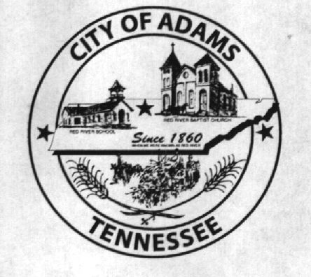
City Meeting
November 1, 2016

The Adams Board of Commissioners met in regular session on Tuesday, November 1, 2016, at 7:00 p.m. in the Bell School Auditorium. Mayor Mary Mantooth, Wayne Evans and Michael Harbert were present.

Item 1: Open With Prayer

Mayor Mantooth asked Robert Evans to open with a word of prayer. Following the word of prayer, Mayor Mantooth requested all in attendance stand for the Pledge of Allegiance.

Item 2: Minutes

Minutes of the October 4, 2016, meeting was read. There being no additions or corrections, Mayor Mantooth moved that the minutes be approved as read. The minutes stand approved with no corrections or additions.

Item 3: Financial Report

The financial report was presented. There being no corrections, Mayor Mantooth moved that the financial report be approved as presented. The financial report stands approved with no corrections or additions.

Item 4: Ordinance Number 2016-008 Amending FY2017 Budget Previously Passed by Ordinance 2016-004 (Second Reading)

The City Recorder read the title of Ordinance Number 2016-008 amending the fiscal year 2017 budget previously passed by Ordinance Number 2016-004. Wayne Evans made a motion to approve Ordinance Number 2016-008 upon second reading. Mike Harbert seconded the motion. Motion carried by voice vote: 2 for; 0 opposed.

Item 5: ADA Compliant Ramp

The City Recorder asked the Commissioners if they were ready to make a decision on the ADA compliant ramp. Wayne Evans stated that he still had someone he was trying to get in touch with, so the matter was postponed until next meeting.

Item 6: Christmas in the Park Update

The City Recorder updated the Board of Commissioners on Christmas in the Park, stating Denny Lowe has coordinated volunteers to assist in putting up all the Christmas decorations. Additionally, flyers for the parade and home decorating have been sent out. Mayor Mantooth stated she spoke with the Fletcher’s and they graciously accepted the City’s offer to be Grand Marshalls for the parade.

Item 7: Bonus for City Hall Staff

The Board of Commissioners discussed the yearly bonus for the City Hall staff. The City Recorder suggested that since there are only two people in the office, who are both instrumental in the operation, both be given the same amount. Wayne Evans made a motion to give each of the City Hall staff members a bonus of $500. Mike Harbert seconded the motion. Motion carried by voice vote: 2 for; 0 opposed.

Item 8: Updates from the Departments

Fire Department – Chief Brown stated he had nothing to report. Donovan Tucker inquired about Toys for Tots to see how he would go about obtaining the items he needs toward the end of December. Mayor Mantooth informed Mr. Tucker that all he needed to do was to get in contact with the City Recorder, who would handle the specifics and ensure he had what he needed.
Recreation Department – Eddie Hobgood reminded the Commissioners and public about the Chili Cook-Off fundraiser to be held November 12, 2016 at 5:00 pm.
Museum Department – Cathy Lowe had nothing to report, but stated the Museum Board will not meet again until January.

There being no further business, Mary Mantooth moved to adjourn. Wayne Evans seconded the motion. Meeting adjourned at 7:16 p.m.

Respectfully submitted,

________________________________ ____________________________________
Dawn Ray, City Recorder Mary Mantooth, Mayor

