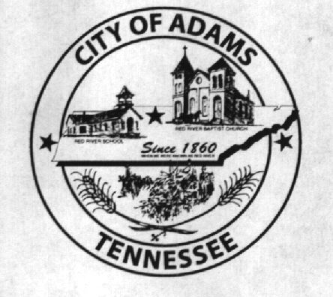
City Meeting
October 4, 2016

The Adams Board of Commissioners met in regular session on Tuesday, October 4, 2016, at 7:00 p.m. in the Bell School Auditorium. Mayor Mary Mantooth, Wayne Evans and Michael Harbert were present.

Item 1: Open With Prayer

Mayor Mantooth asked Denny Lowe to open with a word of prayer. Following the word of prayer, Mayor Mantooth requested all in attendance stand for the Pledge of Allegiance.

Item 2: Minutes

Minutes of the September 6, 2016, meeting was read. Mike Harbert requested language be added to Item 4 to include Vice Mayor Wayne Evans stating he could not find his copy of the purchasing policy. Mayor Mantooth moved that the minutes be approved with stated addition. Minutes stand approved with stated addition.

Item 3: Financial Report

The financial report was presented. There being no corrections, Wayne Evans moved that the financial report be approved as presented. The financial report stands approved with no corrections or additions.

Item 4: Ordinance Number 2016-007 OSHA (Second Reading)

The City Recorder read the title of Ordinance Number 2016-007 regarding OSHA changes. Wayne Evans made a motion to approve Ordinance No. 2016-007 upon second reading. Mike Harbert seconded the motion. Motion carried by voice vote: 2 for; 0 opposed.

Item 5: ADA Compliant Ramp

The City Recorder asked the Commissioners if they were ready to make a decision on the ADA compliant ramp. Wayne Evans stated that he still had someone he was trying to get in touch with, so the matter was postponed until next meeting.

Item 6: Ordinance Number 2016-008 Amending FY2017 Budget Previously Passed by Ordinance 2016-004

The City Recorder read the title and summary of Ordinance Number 2016-008 amending the fiscal year 2017 budget previously passed by Ordinance Number 2016-004. Wayne Evans made a motion to approve Ordinance Number 2016-008 upon first reading. Mike Harbert seconded the motion. Motion carried by voice vote: 2 for; 0 opposed.

Item 7: JBHS Baseball Club Donation

The City Recorder presented the Commissioners with a letter from JBHS requesting a $200 sponsorship for an upcoming event. Mike Harbert made a motion to approve the $200 donation to JBHS Baseball Club. Wayne Evans seconded the motion. Motion carried by voice vote: 2 for; 0 opposed.

Item 8: Charles Stuard’s Request for a City of Adams Sign on Maxey Road

Charles Stuard contacted City Hall and request the city place a couple signs pointing out the direction of City Hall. Mr. Stuard stated, especially during this time of year, with the plays, people are unclear where to turn to get to Bell School and they end up turning around on or near his property. Wayne Evans made a motion to order two signs that will point to the direction of City Hall. Mayor Mantooth seconded the motion. Motion carried by voice vote: 2 for; 0 opposed.

Item 9: Fire Chief, Ray Brown’s Retirement

Mayor Mantooth asked Ray Brown if he would like to share the information he shared with her previously regarding his retirement. Chief Brown stated he did not remember said conversation and had no immediate plans for retirement, but was in the process of training someone to do the paperwork.

Item 10: Christmas in the Park

After a brief discussion between the Commissioners and the public, it was decided to extend an invitation to Jimmy and Lucile Fletcher to be the Grand Marshals for the 2016 Christmas in the Park Parade. Mayor Mantooth asked the City Recorder to send a letter of invitation to the Fletcher’s as soon as possible. Denny Lowe was asked if he would be “Santa” again this year. Mr. Lowe graciously accepted the position.

Item 11: Updates from the Departments

Fire Department – Chief Brown stated he was working with East Montgomery to develop a mutual aid contract.
Recreation Department – No Representative
Museum Department – Cathy Lowe had nothing to report, but did state she would decorate the outside museum buildings for the holidays.

Item 12: Other

Jay Hall addressed the Commissioners. Mr. Hall asked for permission to cut down the dead tree in front of Bell School, which is just inside the property line adjacent to the property owned by the Threshermen’s Association. He also requested permission to sow a few rough spots throughout the property. The Commissioners unanimously agreed to allow Mr. Hall to cut the tree down and sow the rough spots.

There being no further business, Mary Mantooth moved to adjourn. Wayne Evans seconded the motion. Meeting adjourned at 7:35 p.m.

Respectfully submitted,

________________________________ ____________________________________
Dawn Ray, City Recorder Mary Mantooth, Mayor

