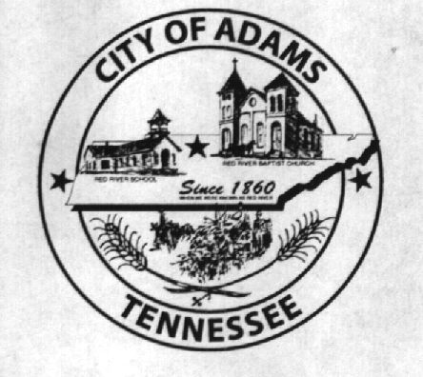
City Meeting
September 6, 2016

The Adams Board of Commissioners met in regular session on Tuesday, September 6, 2016, at 7:00 p.m. in the Bell School Auditorium. Mayor Mary Mantooth, Wayne Evans and Michael Harbert were present.

Item 1: Open With Prayer

Mayor Mantooth asked Denny Lowe to open with a word of prayer. Following the word of prayer, Mayor Mantooth requested all in attendance stand for the Pledge of Allegiance.

Item 2: Minutes

Minutes of the August 2, 2016, meeting was read. There being no corrections or additions, Mayor Mantooth moved that the minutes be approved. Minutes stand approved with no corrections or additions.

Item 3: Financial Report

The financial report was presented. There being no corrections, Wayne Evans moved that the financial report be approved as presented. The financial report stands approved with no corrections or additions.

Item 4: Purchase of New Accounting Software

Gary Jaeckel, from MTAS, addressed the Commissioners regarding Mike Harbert’s concern about the purchasing policy and the use of state contracts. Mr. Jaeckel stated the purchasing policy was completely legal and was designed to save cities money by not having to pay to advertise for sealed bids for purchases less than $10,000. Additionally, Mr. Jaeckel stated cities should always look at companies who have state contracts as there is no bidding required because the state has essentially put its seal of approval on those companies, which also saves cities time and money by not having to formally bid for certain projects. Mr. Jaeckel stated the purchase of the accounting software was morally, ethically, and legally correct. Mike Harbert claimed he never received a copy of the new purchasing policy. The City Recorder assured him that she did put a copy in his binder when the purchasing policy was brought up the first time in a city meeting. The City Recorder went on to say, that it was possible human error was a factor and Mike Harbert did not receive a copy, but if that was the case, Mr. Harbert should not have voted to approve something he did not have a copy of and read. Mike agreed that it was his error voting to approve something he did not read.

Item 5: ADA Compliant Ramp

The City Recorder asked the Commissioners if they were ready to make a decision on the ADA compliant ramp. Wayne Evans stated that he still had someone he was trying to get in touch with, so the matter was postponed until next meeting. The City Recorder asked if, since she was already working on amending the budget, should she add in the proposed cost of the ramp if they decide to approve the project. The Commissioners agreed to have the City Recorder add the proposed amount to the amended budget to be presented at a later date.

Item 6: Update on Commerce Street Railroad Crossing Upgrade

The City Recorder presented the Commissioners with information on the Commerce Street Railroad Crossing upgrade. All information has been sent to TDOT who will be processing a contact. The project is projected to take around a year.

Item 7: Pot Hole Repairs

The City Recorder addressed the Commissioners about the need for pot hole repairs throughout the city. The City Recorder presented prices from two different companies for the asphalt mix used for such repairs. Mike Harbert made a motion to give the City Recorder permission to order one pallet of asphalt repair mix from Ace Hardware. Wayne Evans seconded the motion. Motion carried by voice vote: 2 for; 0 opposed.

Item 8: Speed Limit Signs

The City Recorder updated the Commissioners on increasing the speed limit at two different places on Highway 41 North. The signs have been ordered and will be replaced shortly after we receive them.

Item 9: Drake v. The City of Adams

The above referenced case has been officially dismissed with prejudice.

Item 10: Ordinance Number 2016-007: OSHA

The City Recorder read the title and summarized Ordinance 2016-007 regarding OSHA changes. Wayne Evans made a motion to pass Ordinance 2016-007 upon first reading. Mike Harbert seconded the motion. Motion carried by voice vote: 2 for; 0 opposed.

Item 11: Donation from United Way

The City Recorder informed the Commissioners that the City received 30 energy efficient window air conditioning units from the United Way. Once City Hall has inventoried all the units, the Fire Department will be tasked with donating them to needy residents.

Item 12: Phase I of FY2016 Independent Audit

The City Recorder updated the Commissioners on the FY2016 audit. Karen Stephens and her audit team spent four (4) days at City Hall gathering the information they needed to start the audit. Everything went smoothly and we should have a management report to review sometime in October.

Additional Topics:

Mary Mantooth stated she was no longer wanting to be on the ACHWS Water Board. Wayne Evans stated he would fill the position until someone else was appointed by the Board of Commissioners.

Ray Brown, Fire Chief, was asked if he had any information to bring before the commissioners. Ray said he did not.

Cathy Lowe, representing the Museum, was asked if she had any information to bring before the commissioners. Cathy said she did not.

Steve Ayres, a representative of the Adams Cedar Hill Water System, addressed the commissioners with their proposal to become a water authority. He presented the commissioners with a resolution, done by their attorney Don Scholes, wherein the City of Adams would hold a public hearing about the possibility of becoming a water authority. The resolution was not a city resolution; therefore, nothing could be passed. The commissioners informed Steve they would look at the resolution he presented and discuss it at a future date.

There being no further business, Mary Mantooth moved to adjourn. Wayne Evans seconded the motion. Meeting adjourned at 7:55 p.m.

Respectfully submitted,

________________________________ ____________________________________
Dawn Ray, City Recorder Mary Mantooth, Mayor

