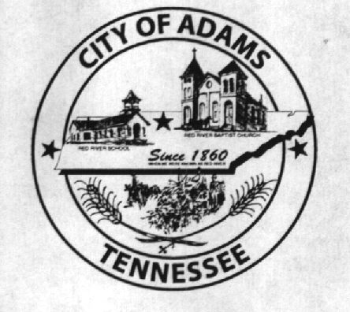
City Meeting
February 8, 2018

The Adams Board of Commissioners met in regular session on Thursday, February 8, 2018, at 7:00 p.m. in the Bell School Auditorium. Mayor Mary Mantooth and Vice Mayor Evans were present.

Item 1: Open With A Prayer

Mayor Mantooth asked Robert Evans to open with a word of prayer. Following the word of prayer, Mayor Mantooth requested all in attendance stand for the Pledge of Allegiance.

Item 2: Minutes

Minutes of the January 11, 2018 meeting was read. There being no additions or corrections, Mayor Mantooth moved the minutes be approved as read. The minutes stand approved as read with no additions or corrections.

Item 3: Financial Report

The financial report was presented. There being no corrections, Mayor Mantooth moved that the financial report be approved as presented. The financial report stands approved with no corrections or additions.

Item 4: ADA Compliant Ramp

Mayor Mantooth stated we had an increase in Local Option Sales Tax and a good way to use this money would be to go ahead with the ADA compliant ramp for Bell School. Mayor Mantooth went on to say she has a contact who may be interested in the project. The City Recorder reiterated that if they choose another vendor than the one we already have a quote on, the project will have to be bid out. Vice Mayor Evans agreed to postpone this discussion until next month’s meeting wherein the Mayor will have the information from her vendor.

Item 5: Beer Permit (Dollar General)

The City Recorder stated Dollar General finally paid the annual fee for their beer permit. Mayor Mantooth and Vice Mayor Evans agreed to renew this permit and signed off on it.

Item 6: Resolution Number 2018-011 Transferring Assets to the West Robertson Water Authority

The City Recorder read the title and summary of Resolution Number 2018-011 transferring the assets to the West Robertson Water Authority after the GO Bond is paid in full. Mayor Mantooth asked Stephen Ayres if this was the type of document he wanted them to pass. Stephen Ayres responded that the document which was presented would not be sufficient for what his bond counsel is requesting. He further stated that there is specific language required per the bond counsel, but he does not know exactly what that information is yet. Mr. Ayres also stated that he has been stalled and mistreated with regard to the transition from the ACHWS to the new water authority. Mr. Ayres said that the city’s attorney, as well as city hall, had known about the request to transfer the assets for two weeks and never responded. Mayor Mantooth said that she had no knowledge of this request until he contacted her this past Tuesday (February 6, 2018). Mr. Ayres said that he didn’t feel he should have to contact her because the city should be doing its job. He went on to say that he will have his lawyer draw up the document transferring the assets owned by the City of Adams to the West Robertson Water Authority and forward it to the city and the city’s attorney for review.
Item 7: Updates from Departments

The Fire Chief stated he received the air paks and the vendor is scheduled to come to the fire department meeting next Tuesday to get 10 guys fitted for the turn out gear.

Matt Carroll stated sign-ups are over and they have ordered the uniforms. Additionally, the opening day ceremony will be held on Saturday, April 21, 2018.

Mayor Mantooth represented the museum and stated the museum board agreed to move $15,000 from the checking account and invest it in LGIP. Both Mayor Mantooth and Vice Mayor Evans agreed to this transfer and investment. Additionally, Vice Mayor Evans asked that $200,000 be moved from the general fund checking account and invested in the LGIP. Both Mayor Mantooth and Vice Mayor Evans agreed to this transfer and investment.

Item 9: Other Business

Mayor Mantooth spoke about the culverts needing to get cleaned out. Fire Chief Brown stated he thought TDOT was responsible to clean out the culverts on the state roads.

There being no further business, Mayor Mantooth moved to adjourn. Vice Mayor Evans seconded the motion. Meeting adjourned at 7:16 p.m.

Respectfully submitted,

________________________________ ____________________________________
Dawn Ray, City Recorder Mary Mantooth, Mayor

