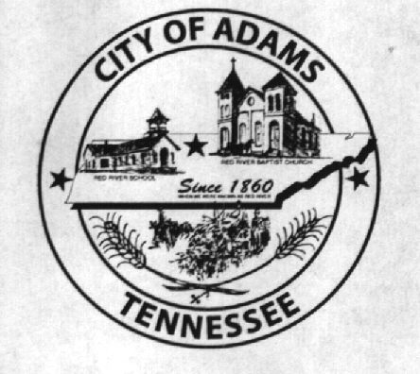
City Meeting
May 2, 2017

The Adams Board of Commissioners met in regular session on Tuesday, May 2, 2017, at 7:00 p.m. in the Bell School Auditorium. Mayor Mary Mantooth, Wayne Evans and Will David Goodman were present.

Item 1: Open With Prayer

Mayor Mantooth asked Tyler Estep to open with a word of prayer. Following the word of prayer, Mayor Mantooth requested all in attendance stand for the Pledge of Allegiance.

Item 2: Minutes

Minutes of the April 4, 2016 meeting was read. There being no additions or corrections, Mayor Mantooth moved the minutes be approved as read. The minutes stand approved with no corrections or additions.

Item 3: Financial Report

The financial report was presented. There being no corrections, Mayor Mantooth moved that the financial report be approved as presented. The financial report stands approved with no corrections or additions.

Item 4: Ordinance Number 2017-012 (First Reading)

The City Recorder read the title and summary of Ordinance Number 2017-012: Annual Budget for F 2018. Vice Mayor Evans made a motion to approve Ordinance Number 2017-012 upon first reading. Mayor Mantooth seconded the motion. Roll call vote: Mantooth: Aye; Evans: Aye; Goodman: Aye.

Item 5: Ordinance Number 2017-013 (First Reading)

The City Recorder read the title and summary of Ordinance Number 2017-013: mending the Place and Day of the Monthly City Meeting. Motion was made by Commissioner Goodman to approve Ordinance Number 2017-013 upon first reading. Vice Mayor Evans seconded the motion. Roll call vote: Mantooth: Aye; Evans: Aye; Goodman: Aye.

Item 6: Ordinance Number 2017-014 (First Reading)

The City Recorder read the title and summary of Ordinance Number 2017-014: Amending the Surety Bond Amounts. Vice Mayor Evans made a motion to approve Ordinance Number 2017-014 upon first reading. Mayor Mantooth seconded the motion. Roll call vote: Mantooth: Aye; Evans: Aye; Goodman: Aye.

Item 7: Water Authority Act and Proposed Timeline

Nathan Hunt, Attorney for the City of Adams, TN, addressed the Board of Commissioners and the public with regards to the Adams Cedar Hill Water System becoming a Water Authority. After giving a brief synopsis of the history of the water system, Nathan discussed the proposed draft of the water authority act wherein the City of Adams is the creating entity and Cedar Hill a participating entity. Nathan went on to say this document is simply a draft at this point and has been sent to Phyllis Morris, Attorney for Cedar Hill for her review. Nathan stated there will be a five (5) person board which will be limited to two (2) consecutive terms. Billy Vogle questioned the six (6) month deadline for paying off the G.O. Bond obligation and requested language stating if they were close to finalizing the loan by the deadline (which he asked to also be increased to at least 9 months) the creating entity would not disband the water authority. Billy also stated banks are receptive to giving ACHWS the money to pay off the loan and TAUD says they can get them the money. Gene Davidson talked about the board for the water system and the reason they were given unlimited life was because it was difficult to find people to be on the board. He also stated the rumors of the water system being in arrears for three years was false, that down the road the Adams and Cedar Hill lines will need to be replaced, and that he has stayed on the water board for longer than he wanted to. Eddie Hobgood addressed the Board as a water customer and asked if a majority of the newly created water authority board would be from the city limits of Adams. He said he wanted to ensure each area serviced by the water system be represented on the new board. The Commissioners agreed to this and asked Nathan to change the way the newly created board would be set up in the following way: the Board of Commissioners would appoint four members of the water authority board, one will be the Mayor or Commissioner, one from Route 3, one from Route 4 and one picked at large. Nathan stated he will make the changes agreed upon during this meeting and forward an updated act to Phyllis Morris. Any suggested revisions will be sent to Nathan.

Item 8: Updates from the Departments

Chief Ray Brown addressed the Board of Commissioners requesting permission to spend between $1,000 to $1,250 on a transmission for one of the fire trucks. Since the fire department has more than enough money to cover this cost, the Commissioners granted Chief Brown’s request to get the transmission fixed.

Eddie Hobgood stated the Rec Club had a successful opening day ceremony. He asked the Board of Commissioners if they would put up signs around the ballfields stating only service animals are permitted. Eddie stated there was an incident recently where a spectator brought a dog and kept walking it in front of another spectator who is severely allergic to dogs. Mayor Mantooth said she would look into that for him.

The museum department had nothing to report.

There being no further business, Mayor Mantooth moved to adjourn. Vice Mayor Evans seconded the motion. Meeting adjourned at 7:46 p.m.

Respectfully submitted,

________________________________ ____________________________________
Dawn Ray, City Recorder Mary Mantooth, Mayor

