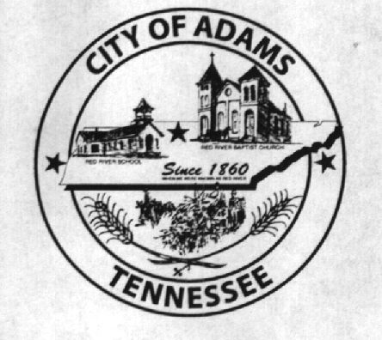
City Meeting
September 14, 2017

The Adams Board of Commissioners met in regular session on Thursday, September 14, 2017, at 7:00 p.m. in the Bell School Auditorium. Mayor Mary Mantooth, Vice Mayor Wayne Evans and Commissioner Will David Goodman were all present.

Item 1: Open With A Prayer

Mayor Mantooth asked Dean to open with a word of prayer. Following the word of prayer, Mayor Mantooth requested all in attendance stand for the Pledge of Allegiance.

Item 2: Minutes

Minutes of the August 10, 2017 meeting was read. Mayor Mantooth moved the minutes be approved as read. The minutes stand approved as read.

Item 3: Financial Report

The financial report was presented. There being no corrections, Mayor Mantooth moved that the financial report be approved as presented. The financial report stands approved with no corrections or additions.

Item 4: HVAC Service Agreements

The City Recorder presented a spreadsheet with the information obtained from several HVAC companies to provide spring and fall service. Vice Mayor Evans made a motion to approve AirServ (formally known as Morton Mechanical) to provide this service for the city. Mayor Mantooth seconded the motion. Motion passed by voice vote: 2 for; 0 opposed.

Item 5: Easement Contracts from Croft & Associates

The City Recorder presented the contracts received from Croft & Associates regarding the easements required for the Logan/Todd, City of Springfield water line project. Vice Mayor Evans made a motion to approve the presented easement contracts. Mayor Mantooth seconded the motion. Motion passed by voice vote: 2 for; 0 opposed.

Item 6: Donation to JBHS Baseball Club

The City Recorder presented the donation request from JBHS Baseball Club. The Board of Commissioners agreed to give a donation of $200, which is the same as years past.

Item 7: Recreation Department – New Director

Matt Carol addressed the Board of Commissioners stating he was interested in being the new director and baseball commissioner for the upcoming season, replacing Eddie Hobgood. The Board of Commissioners all agreed to place Mr. Carol in this position.

Item 8: Josh Burnett – Scenic Valley Estates Road

Mr. Burnett did not attend this meeting; therefore, this matter was not discussed.

Item 9: Christmas in the Park – Grand Marshall

Mayor Mantooth suggested Shelby Jean Brooksher be the Grand Marshall for the upcoming Christmas in the Park Parade. Vice Mayor Evans made a motion to have Ms. Brooksher serve as Grand Marshall. Mayor Mantooth seconded the motion. Motion passed by voice vote: 2 for; 0 opposed.

Item 10: Water Department – Mark Butler, TAUD – Resolution Number 2017-009

Mark Butler was not at this meeting. Stephen Ayers stood in front of the Board of Commissioners and made a statement giving a brief history of the water system, saying there would be more opportunities for grants if the water system became a water authority, and that his first priority would be to pay back the City of Adams for the $1M loan previously taken out on the water system’s behalf. The City Recorder then presented the Commissioners with Resolution Number 2017-009 calling for a public hearing on creating a water authority. Vice Mayor Evans made a motion to approve Resolution Number 2017-009. Commissioner Goodman seconded the motion. Motion carried by voice vote: 2 for; 0 opposed.

Item 11: Updates from Departments

Chief Ray Brown stated he had nothing to report.

The Recreation Department had nothing to report.

Mayor Mantooth spoke on behalf of the Museum stating they are looking to repair some of the cabinets and replace some that cannot be repaired. Mayor Mantooth also stated the Threshermen’s Association has almost completed the installation of lights behind the ballfield.

Item 12: Other Business

Mayor Mantooth stated moving the carport, belonging to the Threshermen’s Association, may not be the best option. Mayor Mantooth stated the carport definitely needed to be spruced up with some paint. The City Recorder asked if the Threshermen’s Association would pay to have the carport painted. Chris Cockrill stated no, they would not pay for the repainting. Mayor Mantooth said the City can pay for the paint. Chris Cockrill stated Billy Vogle would like to have the carport for the Fishermen’s Club. Commissioner Goodman stated that might be a better idea.

The City Recorder stated the pavilion still needed gutters replaced. Although the project had been approved a year and a half ago, it was brought up again due to the cost being accrued in a different fiscal year. The Board of Commissioners all agreed this project should be completed as soon as possible and is in line with the current fiscal year’s budget.

There being no further business, Mayor Mantooth moved to adjourn. Vice Mayor Evans seconded the motion. Meeting adjourned at 7:22 p.m.

Respectfully submitted,

________________________________ ____________________________________
Dawn Ray, City Recorder Mary Mantooth, Mayor

