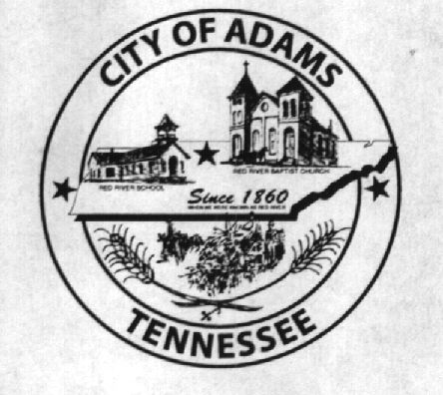
City Meeting
December 14, 2017

The Adams Board of Commissioners met in regular session on Thursday, December 14, 2017, at 7:00 p.m. in the Bell School Auditorium. Mayor Mary Mantooth and Commissioner Will David Goodman were present.

Item 1: Open With A Prayer

Mayor Mantooth asked Donovan Tucker to open with a word of prayer. Following the word of prayer, Mayor Mantooth requested all in attendance stand for the Pledge of Allegiance.

Item 2: Minutes

Minutes of the November 7, 2017 meeting was read. There being no additions or corrections, Mayor Mantooth moved the minutes be approved as read. The minutes stand approved as read with no additions or corrections.

Item 3: Financial Report

The financial report was presented. There being no corrections, Mayor Mantooth moved that the financial report be approved as presented. The financial report stands approved with no corrections or additions.

Item 4: Surveillance System

Commissioner Goodman stated that just because a company has a state contract does not mean that company offers the best price. The City Recorder stated the company we got the quote from has said their pricing would probably be less due to new camera systems being used. Commissioner Goodman requested the City Recorder contact the vendor and ask for another quote. The City Recorder stated since this discussion has been going on for almost a year, she didn’t want to waist the vendor’s time if they were not going to make a decision. Commissioner Goodman and Mayor Mantooth agreed to make a firm decision at the January meeting if the City Recorder received another quote.

Item 5: Capital Outlay Project

The Commissioners had nothing to report on this matter.

Item 6: Possibility of a 5 Member Board of Commissioners

Commissioner Goodman asked why there was not an ordinance for the 5-member commission. The City Recorder informed him that she contacted MTAS and their legal department is working on it because they did not have a sample document. The City Recorder also stated there is plenty of time for this because we do not have to notify the election commission until May.

Item 7: Ordinance Number 2017-015 An Ordinance dissolving the Joint Venture known as the ACHWS and Establishing the West Robertson Water Authority (Second Reading)

The City Recorder read the title of Ordinance Number 2017-015: An Ordinance dissolving the Joint Venture Known as the ACHWS and Establishing the West Robertson Water Authority. Commissioner Goodman made a motion to pass said ordinance upon second reading. Mayor Mantooth seconded the motion. Motion passed by roll call vote: Mantooth – Aye, Goodman – Aye.

Item 8: Ordinance Number 2017-016 An Ordinance Amending FY2018 Budget (First Reading)

The City Recorder read the title and summary of Ordinance Number 2017-016 An Ordinance Amending FY2018 Budget. Commissioner Goodman made a motion to pass said ordinance upon first reading. Mayor Mantooth seconded the motion. Motion passed by roll call vote: Mantooth – Aye, Goodman – Aye.

Item 9: Resolution Number 2017-010 Naming the Board of Commissioners for the West Robertson Authority and Initial Terms

The City Recorder read the title and summary of Resolution Number 2017-010 Naming the Board of Commissioners for the West Robertson Authority and Initial Terms. Commissioner Goodman made a motion to pass said resolution. Mayor Mantooth seconded the motion. Motion passed by roll call vote: Mantooth – Aye, Goodman – Aye.

Item 10: Open Sealed Bid Packets for RR Crossing Upgrades

No bids were received for this project.

Item 11: Open Sealed Bid Packets for Fire Department Air Paks

No bids were received for this project.

Item 12: Open Sealed Bid Packets for Fire Department Turn-Out Gear

One bid packet was received from Safe Industries for a total amount of $20,390.00. It was decided by the Fire Chief and agreed to by the Commissioners that this was not sufficient to make the purchase. The City Recorder will publish new bid packets for both the turn out gear and air paks. Additionally, the fire chief will give the City Recorder information on specific vendors to send the bid packets to in order to get a better response.

Item 13: Updates from Departments

The Fire Chief had nothing to report.

Matt Carroll stated sign-ups for the upcoming baseball and softball season will be January 13, 20, and 27, 2018 in the Bell School Gym.

The Museum Department did not have a representative at the meeting.

Item 14: Other Business

Stephen Ayres stated they are working on getting the drop box installed on the Bell School grounds for water department payments.

Commissioner Goodman asked if there was any more information about getting with the City of Springfield to hire one of their building codes inspectors. Mayor Mantooth informed him she spoke with Mayor Schneider who stated they did not have one available right now, but should have someone willing to help in the near future.

There being no further business, Mayor Mantooth moved to adjourn. Commissioner Goodman seconded the motion. Meeting adjourned at 7:33 p.m.

Respectfully submitted,

________________________________ ____________________________________
Dawn Ray, City Recorder Mary Mantooth, Mayor

