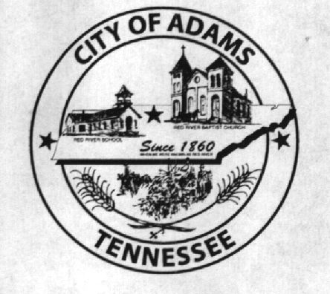
City Meeting
January 11, 2018

The Adams Board of Commissioners met in regular session on Thursday, January 11, 2018, at 7:00 p.m. in the Bell School Auditorium. Mayor Mary Mantooth, Vice Mayor Evans and Commissioner Will David Goodman were present.

Item 1: Open With A Prayer

Mayor Mantooth asked Stephen Ayers to open with a word of prayer. Following the word of prayer, Mayor Mantooth requested all in attendance stand for the Pledge of Allegiance.

Item 2: Minutes

Minutes of the December 14, 2017 meeting was read. There being no additions or corrections, Mayor Mantooth moved the minutes be approved as read. The minutes stand approved as read with no additions or corrections.

Item 3: Financial Report

The financial report was presented. There being no corrections, Mayor Mantooth moved that the financial report be approved as presented. The financial report stands approved with no corrections or additions.

Item 4: Surveillance System

The City Recorder presented the new quote from Protection 1 for a surveillance system for Bell School Grounds. Vice Mayor Evans made a motion to approve this project. Commissioner Goodman seconded the motion. Motion passed by voice vote: 2 for; 0 opposed.

Item 5: Sealed Bid Packets for Fire Department Air Paks

The City Recorder presented the one bid received for Air Paks. The bid packet was from Municipal Emergency Services in the amount of $28,260.00. Vice Mayor Evans made a motion to approve the bid from MES. Commissioner Goodman seconded the motion. Motion passed by voice vote: 2 for; 0 opposed.

Item 6: Sealed Bid Packets for Fire Department Turn Out Gear

The City Recorder presented the bids received for the Fire Department Turn Out Gear. Bids were received from the following companies: Safe Industries for $20,390; Midsouth for $20,580 plus $150.00 for shipping and handling; NAFECO for $17,450.00; and MES for $19,149.00. Vice Mayor Evans made a motion to accept the bid from MES due to the quality of suit and leather boots. Commissioner Goodman seconded the motion. Motion passed by voice vote: 2 for; 0 opposed.

Item 7: Beer Permits

The City Recorder presented the certificate for the annual beer permit for Adams Market. All three commissioners agreed to renew their beer permit. The City Recorder also informed the commissioners that Dollar General had been informed in December to remit the $100 annual fee, but had yet to do so.

Item 8: Updates from Departments

The Fire Chief asked that if money remained under capital outlay projects for the fire department, he be allowed to use it to purchase new radios. The commissioners agreed.

Matt Carroll had nothing to report for the Recreation Department

The Museum Department did not have a representative at the meeting.

Item 9: Other Business

Stephen Ayres stated they are working on setting up the West Robertson Water Authority and getting a new FEIN from the IRS.

Mayor Mantooth stated the city needs to do something about the outdoor restrooms. Either upgrade them or tear them down and just get portables for events. Additionally, Mayor Mantooth stated the ceilings in the gym and auditorium need attention. Chief Brown stated the roofs really need to be tarred every three years. Mayor Mantooth suggested the City Recorder get a quote for the tarring of the bell school roofs.

There being no further business, Mayor Mantooth moved to adjourn. Commissioner Goodman seconded the motion. Meeting adjourned at 7:37 p.m.

Respectfully submitted,

________________________________ ____________________________________
Dawn Ray, City Recorder Mary Mantooth, Mayor

