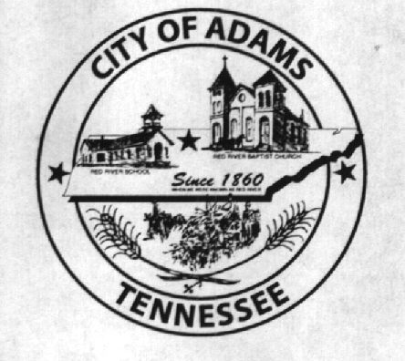
City Meeting
June 14th 2018

The Adams Board of Commissioners met in regular session on Thursday, June 14th , 2018, at 7:00 p.m. in the Bell School Auditorium. Mayor Mary Mantooth, Vice Mayor Evans and Commissioner Will David Goodman were present.

Item 1: Open With A Prayer
Mayor Mantooth asked Robert Evans to open with a word of prayer. Following the word of prayer, Mayor Mantooth requested all in attendance stand for the Pledge of Allegiance.

Item 2: Minutes
Minutes of the May 10th, 2018 meeting was read. Mary asked if there were any corrections and with no corrections to be made the minutes were approved.

Item 3: Financials
The financials were presented along with line item adjustments, Evans then moved to approve the minutes, Mary seconded the motion and they were approved with no corrections.

Item 4: Ordinance 2018-018 FY2019 Budget Second Reading
The second reading of Ordinance 2018-018 for the FY2019 Budget was presented to the Commissioners. Wayne Evans made a moved to vote on the Ordinance and Mary Mantooth seconded the motion. Roll Call Vote: Goodman: nay; Mantooth: aye; Evans: aye

Item 5: Ordinance 2018-019 1st Reading of the Updated Occupational Safety and Health Program Plan
The first reading of the Ordinance to update the Occupational Safety and Health Program Plan. The update included the statement that All work related inpatient hospitalizations, amputations, and loss of an eye must be reposted to TOSHA within 24 hours. The update also was to update the appendix for work stations and to remove the Fire Department from it since they are a Volunteer Fire Department. Goodman moved to adopt the ordinance and Evans seconded it. Roll Call Vote: Goodman: aye; Mantooth; aye; Evans: aye

Item 6: Building Codes
The Commission was presented information from The Municipal Inspection Partners to provide inspections from building codes along with a price list for service fee’s. Mayor Mantooth advised she had met with him and talked to him and road around town looking at things that needed to be addressed. With further information needed it was decided to table this and invite him to the next city meeting to provide further information.

Item 7: Fencing at Bell School
A quote was presented to the commissioners from Alley Fencing for a plank fence to be put around the Bell School and to remove the chain link. The quote was for $10,854.06. Discussion was held about the price and about it being wood and the upkeep to it. Goodman had said he would look into some other options. It was agreed to table this for the time being.

Item 7: Closing off thru June 26th to July 9th
Discussion was held over how to cover the office while the city clerk was on vacation. It was mentioned to have someone try to cover the office from 10:00 to 2:00 during this time. Lisa Jernigan had advised she had talked to Sherry Hall who had volunteered to come and help as needed when she was able to. It was agreed they would find someone to cover the office 4 hours a day during that time.

Item 8: Last Water Payment
Mayor Mantooth advised the water department would be making the final payment this month and instead of them paying the City and the City paying off the loan the Water Department would make that final payment and provide documentation to the City of the last payment.

Item 9: Cleaning of Bell School
The city had received two bids for the cleaning. One with Christine Brown for $125 a week and the other bid from Denny Lowe for $175.Cleaning would start on July 1st of 2018. Mayor Mantooth made a motion to accept the bid for $125 with Christine Brown, Evans seconded the motion. Roll Call Vote: Goodman: aye; Mantooth: aye; Evans: aye

Other Departments:
Fire Chief Ray Brown advised that he had received everything now. Matt Carroll advised that there closing day went well and they are ready to start all-star tournaments.

Other Business:
Will David Goodman asked about the curtains at the pavilion and when they were going to get put up. Mayor advised she would check on it next week when they meet again.

Jay Hall advised there were many pot holes around the city and he had made a list of where they are and advised there were many street signs missing. Wayne Evans said he and Denny Lowe would get together and try to see about the holes to patch. Ray Brown said he would check and see what signs we had that could be put up and we could order the others.

Will David Goodman advised he had been approached again about all the street lights that needed to be replaced. Wayne Evans advised he would get out and put tape around the ones that need to be fixed.

Jay Hall asked if the building by the maintenance building was for rent. Mayor Mantooth advised that is was and someone had already contacted us about renting it for the summer. The gravel down at the ball field was discussed and Jay Hall had said it was a muddy and hard to mow and that we were in need of more gravel. Matt Carroll advised his wife worked at Roger’s group and that he could help to get it from there. Jay Hall had advised he would like to level it out before they bring it. It was decided to let Matt Carroll and Jay Hall handle this.

The border for the playground was brought up. Mayor Mantooth advised she and I had gotten prices on the border for 6 inch and 12 inch and preferred the 12 inches because it would hold more of the mulch in. It was decided to go ahead and order the border. Jay Hall had advised he would remove the cross ties and put in the border and requested to keep the cross ties.

There being no further business, Mayor Mantooth moved to adjourn. Vice Mayor Evans seconded the motion. Meeting adjourned at 7:37 p.m.

Respectfully submitted,

________________________________ ____________________________________
Lisa Jernigan, City Clerk Mary Mantooth, Mayor

