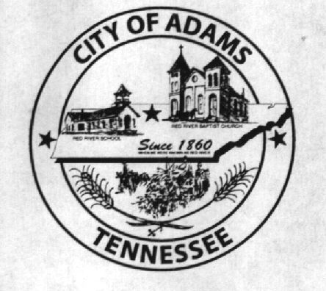
City Meeting
May 10th 2018

The Adams Board of Commissioners met in regular session on Thursday, April 12th, 2018, at 7:00 p.m. in the Bell School Auditorium. Mayor Mary Mantooth, Vice Mayor Evans and Commissioner Will David Goodman were present.

Item 1: Open With A Prayer
Mayor Mantooth asked Tyler Estep to open with a word of prayer. Following the word of prayer, Mayor Mantooth requested all in attendance stand for the Pledge of Allegiance.

Item 2: Minutes
Minutes of the April 12th, 2018 meeting was read. Mary asked if there were any corrections and with no corrections to be made the minutes were approved.

Item 3: Financials
The financials were presented, Will David Goodman them moved to approve the minutes, Wayne seconded the motion and they were approved with no corrections.

Item 4: Ordinance 2018-018 FY2019 Budget First Reading
The Ordinance was presented to the Commissioners. Discussion was held regarding the Capital outlay projects over the elevator. Wayne Evans made a moved to vote on the Ordinance and Mary Mantooth seconded the motion. Roll Call Vote: Goodman: nay; Mantooth: aye; Evans: aye

Item 5: Rail Road Closure on Murphy St/Rail Road Street and the Vaughan Property Line
Discussion was held about the rail road closure on Murphy Street. TDOT is willing on paying the City 20,000 for the closure. Mayor Mantooth advised she talked to the Ashabraners and they were in favor of the closure. Mary moved for the closure and Evans seconded the motion. Roll Call Vote: Goodman: aye; Mantooth: aye; and Evans: aye

Daniel Vaughan and Shirley Wehrenberg were present to voice their concerns on the closing off Rail Road Street at the Vaughan property line and deed it over to them. Wehrenberg had concerns on getting to her property and the Vaughan’s were wanting to combine both parcels. The commissioners heard their concerns and advised they would take everything into consideration and that we were awaiting advise from out attorney

Item 6: Bell School Cleaning
Bell School cleaning was discussed. Denny Lowe is no longer interested in doing the cleaning and the city is in need of a new person to do the cleaning. It was decided to contract it out this time instead of treating it as an employee. We had been advised by TOSHA that if its an employee and we supply the chemicals then we are required to train them and keep records of the chemicals. The commission decided to take bids on it and advertise it in local businesses.

Item 7: Spring Trash Pick Up
The commissioners picked the date of June 1st, 2nd and 3rd for the dumpsters to be located at Bell School. Due to outside residents last year bringing there trash here it was decided that we at least put on the post card that they were required to bring the post cards and hopefully it would help keep outside residents away.

Item 7: Building Codes
Mayor Mantooth advised she had tried to call Mike Gupton but was unable to talk to him and that he was supposed to call her back.

Item 8: City Recorder Position
The City Recorder Position was discussed and still under review and being considered. Wayne Evans made a motion to appoint Lisa Jernigan as interim recorder until a decision was made, Mayor Mantooth seconded and all were in favor.

Item 9: Water Leak/Electrical/Outdoor Restrooms
Due to a water leak the City had requested a quote from Rusty’ plumbing. The quoted amount was $3,575, to repair the sinks, commodes and urinals in the outdoor restrooms. Mayor Mantooth moved that we take the bid and update the restrooms, Evans seconded the motion. Roll Call Vote: Goodman: aye; Mantooth: aye; Evans: aye. I was asked to get with Brad Powell on getting another quote on doing the work from a different meter.

Item 10: CSX Bid
The commission was advised that the Rail Road Crossing agreement for the improvement on S Commerce and S Bell Cross road was to spit between the City at 10% and TDOT would pay 90%. The Bid we received from Crown paving was for $85,600. Goodman stated this project would need to start in the next fiscal year after July 1st. Mantooth made a motion to accept the bid and move forward, Evans seconded the motion. Roll Call Vote: Goodman: aye; Mantooth: aye; Evans: aye.

Other Departments:
Fire Chief Ray Brown stated that he had gotten all his turn out gear everything was good but two boots needed to be exchanged for different sizes. He presented the commission with a quote for radios to use the remaining money in his budget this year. The quote for the radio’s was $3,930.90. Mayor Mantooth moved to purchase the radio’s, Wayne seconded the motion. Roll Call Vote: Goodman: aye; Mantooth: aye; Evans: aye.

Matt Carroll from the Recreation club advised they had a great opening day with a big turnout. He reported that the field machine had been stolen. He requested that we call Waste Industries and request a different dumpster that they are able to lock and keep others from placing their own trash in the dumpsters.

Stephen Ayres advised everything was going well and that they had several loan offers. They have a scheduled meeting end of May to meet and sign off on the loan and the City would be paid off by then end of June.

Tyler Estep spoke about the museum and the work they had done cleaning up in the museum.

Mayor Mantooth advised there were still people interested in purchasing the main street building. They are going to get back with her. Goodman mentioned the door being opened again and needed to secured. It was also mention that there was hole there that needed to be covered and secured.

There being no further business, Mayor Mantooth moved to adjourn. Vice Mayor Evans seconded the motion. Meeting adjourned at 7:51 p.m.

Respectfully submitted,

________________________________ ____________________________________
Lisa Jernigan, City Clerk Mary Mantooth, Mayor

