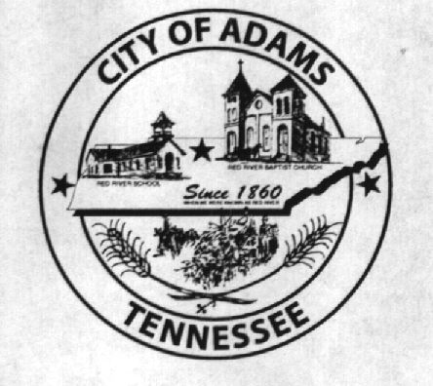
City Meeting
August 9th 2018

The Adams Board of Commissioners met in regular session on Thursday, August 9th 2018, at 7:00 p.m. in the Bell School Auditorium. Mayor Mary Mantooth, Vice Mayor Evans and Commissioner Will David Goodman were present.

Item 1: Open With A Prayer
Mayor Mantooth asked Robert Evans to open with a word of prayer. Following the word of prayer, Mayor Mantooth requested all in attendance stand for the Pledge of Allegiance.

Item 2: Minutes
Minutes of the July 12th, 2018 meeting was read. Mary asked if there were any corrections and with no corrections to be made the minutes were approved.

Item 3: Financials
The financials were presented Evans made a motion to approve the financials, Mary seconded the motion and they were approved with no corrections.

Item 4: Ordinance 2018-020 1st reading of the ordinance the 2018-2019 to amend the budget
The first reading of the ordinance was presented amending the levied property tax to .3491 instead of .42. Wayne made a motion to approve the Ordinance. Roll Call Vote: Goodman: aye; Mantooth: aye; Evans: aye

Item 5: Bid Opening
Bids were opened for the Fire Department for the purchase of a Utility Vehicle. There were two received. Hutson’s with John Deere for $18,195.56 and Country Side Outdoors for $12,499.00. After the commissioners reviewed both bids Wayne Evans made a motion to accept the bid from Country Side Outdoor. Roll Call Vote: Goodman: aye; Mantooth: aye; Evans: aye

Old Business:
Mayor Mantooth advised that we are still in the process of trying to find a new City Attorney. A discussion was held about a CMFO for the city and that the state still requires the city to have a CMFO due to the amount of revenue that the city receives. The commission said they were in the process of trying to find someone who would fill this role for the city.

An update was giving on the Rail Road improvements. The commissioners were advised that Crown Paving had contacted city Hall and due to the original contract being signed in April of 2018 the cost based on the August 2018 TDOT index had increased by $4,775.00 and that CSX was requiring a Railroad Liability Policy before they will assign flaggers. The cost of that policy is $3,000.00. They are needing approval for the increase in cost to begin the project. Wayne Evans made a motion to approve. Roll Call Vote: Goodman: aye; Mantooth: aye; Evans: aye

Mayor Mantooth advised she had been to the Logan Todd meeting regarding the water tank and lines that will go thru Adams. She advised they were about to begin the project of building the water tower any time now and should take approximately a year to complete.

There being no further business, Mayor Mantooth moved to adjourn. Vice Mayor Evans seconded the motion. Meeting adjourned at 7:43 p.m.

Respectfully submitted,

________________________________ ____________________________________
Lisa Jernigan, City Clerk Mary Mantooth, Mayor

