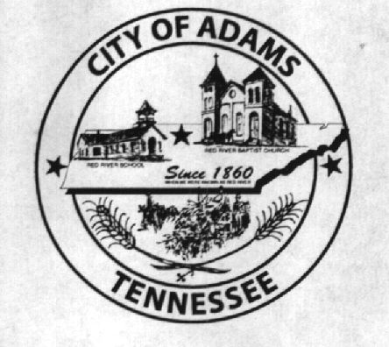
City Meeting
September 13th 2018

The Adams Board of Commissioners met in regular session on Thursday, August 9th 2018, at 7:00 p.m. in the Bell School Auditorium. Mayor Mary Mantooth, Vice Mayor Evans was present. Commissioner Will David Goodman was not in attendance.

Item 1: Open With A Prayer
Mayor Mantooth asked Robert Evans to open with a word of prayer. Following the word of prayer, Mayor Mantooth requested all in attendance stand for the Pledge of Allegiance.

Item 2: Minutes
Minutes of the August 9th, 2018 meeting was read. Mary asked if there were any corrections and with no corrections to be made the minutes were approved.

Item 3: Financials
The financials were presented Evans made a motion to approve the financials, Mary seconded the motion and they were approved with no corrections.

Item 4: 2nd Reading of Ordinance 2018-020
The 2nd reading of the ordinance was presented amending the levied property tax to .3491 instead of .42. Wayne made a motion to approve the Ordinance. Roll Call Vote: Mantooth: aye; Evans: aye

Item 5: Fence Quote
A fence quote from Strait Line Fence was presented and discussion was held to possibly do sections at a time starting at Keysburg Road. Mayor Mantooth made a motion to table this discussion.

Item 6: Play Ground
Quotes were received from Fred Head and Spring Creek Farms. Quotes were for certified mulch and installing the edger around the playground. Spring Creek’s quote was for $4,652.00 and Fred Head’s was for $5,925.00. Wyatt Plank was present at the meeting and requested to submit a quote. The commission agreed to allow him to submit a quote and tabled this till next month.

Item 7: Donation
Jo Byrns Base ball club was requesting a donation of $200.00. Evans made a motion to approve this donation. Roll Call Vote: Mantooth: aye; Evans; aye.

Item 8: City Attorney
Mayor Mantooth advised she had spoken with Jody Dorris and he agreed to be our new city attorney. Mayor Mantooth made a motion to accept him as the new attorney and Evans seconded the motion. Roll Call Vote: Mantooth; aye;Evans; aye.

Old Business:
Main Street buildings were discussed, Mayor Mantooth had advised she had been contacted by someone interested and Wyatt Plank who was in attendance also expressed interest in the buildings. Mayor Mantooth made a motion to put off demolition the buildings another month to give time for those interested to make an offer.

New Business:
Next City Meeting was discussed, with Mayor Mantooth not able to attend it was decided to meet on October 18th instead of October 11th.

There being no further business, Mayor Mantooth moved to adjourn. Vice Mayor Evans seconded the motion. Meeting adjourned at 7:14 p.m.

Respectfully submitted,

________________________________ ____________________________________
Lisa Jernigan, City Clerk Mary Mantooth, Mayor

