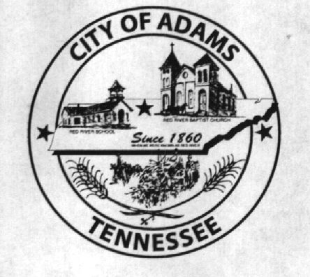
City Meeting
December 13th 2018

The Adams Board of Commissioners met in regular session on Thursday, December 13th 2018, at 7:00 p.m. in the Bell School Auditorium. Mayor Mary Mantooth, Vice Mayor Evans and Donna Boisseua were present.

Item 1: Open with A Prayer
The meeting was called to order and Robert Evans was asked to say the prayer, Mayor Mantooth requested all in attendance to stand for the Pledge of Allegiance.

Item 5: Minutes
Minutes of the November 8th meeting was read. Mayor Mantooth asked if there were any corrections and with no corrections to be made the minutes were approved as read.

Item 6: Financials
The financials were presented. Evans made a motion to approve the financials. Mayor Mantooth seconded the motion and the financials were approved.

Item 7: Leases
Leases for the Bell School were discussed for the upcoming year. Leases were approved with the exception of taking out the hours of operation and adding that payment can be also in the form of cash.

Item 8: Concessions Heat Quotes
Heat in the concessions is not currently working and we had received quotes on fixing and also replacing the heat, $4,685 to replace and $595.82 to repair it. It was discussed why heat was ever put in the concession stand since the water is to be drained in the winter for winterization and that possibly it was due to when Junior Pro Football practiced on the grounds. It was decided it was no longer needed and to not fix or replace at this time.

Item 9: Public Entity Partners/Property Loss Survey
The city clerk advised our insurance company had come to the Bell School and on the grounds and all the buildings and completed a survey with recommendations for extension cords to be removed and add more electrical outlets and fire extinguishers to be added and tagged for inspections, the basement and other areas to have cleaning and unneeded items removed. We have 60 days to reply and advise how we are going to fix the problems discussed in the survey. The commissioners advised that Ray Brown could help on the extinguishers and that we could help to clean in the other areas.

Item 10: CSX Murphy St. Closure
The closure was discussed for barricades for the closure of the road at railroad on Murphy St. The city has received quotes for the barricades for $35 a piece and we would need approximately 8 of them. Don Toothman has agreed to help move them for $300. CSX would provide temporary ones but the City would need to furnish permanent ones along with the signage for the road closure. The signs have been ordered and we are waiting on our attorney to review and sign the contract and return it to us to move forward.

Other Business:
Mayor Mantooth recognized Chris Cockrill for his service on the Water Board serving as the representative for the Engineer. With this position being opened Mayor Mantooth recommended Megan Baird be appointed to the Board as she has a degree in Engineering at West Point, all were in favor.

Adams Market Beer Permit is up for renewal and they have paid their permit. The commissioners approved this year permit and signed it.

There being no further business, Mayor Mantooth moved to adjourn. Vice Mayor Evans seconded the motion. Meeting adjourned at 7:22 p.m.

Respectfully submitted,

________________________________ ____________________________________
Lisa Jernigan, City Clerk Mary Mantooth, Mayor

