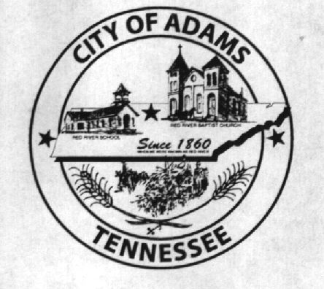
City Meeting
May 9th, 2019

The Adams Board of Commissioners met in regular session on Thursday, May 9th 2019, at 7:00 p.m. in the Bell School Auditorium. Mayor Mantooth, Vice Mayor Evans and Commissioner Boisseau were present.

Item 1: Open with A Prayer
The meeting was called to order and Greg Lynn was asked to say the prayer. Mayor Mantooth requested all in attendance to stand for the Pledge of Allegiance.

Item 2: Minutes
Minutes of the April 11th meeting were read. Mayor Mantooth asked if there were any additions or corrections and with no corrections to be made the minutes were approved as read.

Item 3: Finances
The financials were presented. Commissioner Boisseau made a motion to approve the financials. Mary Mantooth seconded the motion and the financials were approved.

Item 4: Zoning Ordinance 2019-021
The second reading of Zoning Ordinance 2019-021 took place. Commissioner Boisseau made the motion to pass the second reading of Zoning Ordinance 2019-021 and Vice Mayor Evans seconded the motion. A rollcall was made; Mayor Mantooth, “Aye”, Vice Mayor Evans, “Aye”, and Commissioner Boisseau, “Aye”.

Item 5: Ordinance 2019-022
The first reading of Ordinance 2019-022 took place. Commissioner Boisseau made the motion to approve the first reading and Vice Mayor Evans seconded the motion.

Item 6: Fire Truck Purchase
Fire Chief, Ray Brown, requested to buy a new rescue truck for $24,000 for the Fire Department if funds were available. Mr. Brown was advised the Fire Department did have the funds to purchase the truck and it would be placed on the insurance policy. A motion by Commissioner Boisseau was made to approve the spending. Vice Mayor Evans seconded the motion. A roll call was made; Mayor Mantooth, “Aye”, Vice Mayor Evans, “Aye”, Commissioner Boisseau. “Aye”.

Item 7: Update Single Wide Trailer Ordinance
The board were all in favor to look at updating the ordinance on single wide trailers within the city limits.

Item 8: Montgomery County Cattle Association Donation
A motion by Vice Mayor Evans was made to donate $150 to the Montgomery County Cattle Association. Commissioner Boisseau seconded the motion.

Item 9: Cub Scouts & Troops
Mr. Greg Lynn, Cub Master of Pack 454, presented a plaque to the City of Adams in recognition of the outstanding support to the Scouts and Youth in the Adams and Cedar Hill Area. Greg asked to use Room 201 to store the Scouts’ materials and historical history. The Scouts have agreed to do projects and tasks around the city in exchange for using Room 201. The board agreed to rent the room to the Scouts for $1 a year and for the Scouts Flags to be placed on city grounds. Commissioner Boisseau made a motion. Vice Mayor Evans seconded the motion and all were in favor.

New Business:
A discussion occurred regarding the score boards being hooked up at the ball field. The City recorder was advised to get in touch with Matt Carroll regarding electrical work.

There being no further business, Mayor Mantooth moved to adjourn. Vice Mayor Evans seconded the motion. Meeting adjourned at 7:33 p.m.

________________________________ ____________________________________
Anna Luke, City Recorder Mary Mantooth, Mayor

